Daily Notebook & Social Networking Updater
MCA 6th Semester
CMC-60(Final Project)

Anirban Nandy
Enrollment No-105057536

Table of Contents
Introduction & Objective of the Project: 3
Introduction 3
Objective 5
Project Category: 5
Hardware and Software Specification 5
Hardware Requirement 5
Software Requirement 6
Project Structure: 6
Tools/Platforms used (Hardware/Software): 7
Hardware: 7
Software: 7
Any Client/Industry: 7
REQUIREMENTS AND ANALYSIS 8
Problem Definition 8
Requirements Specification 8
Functional Requirement 8
Register User 8
Login User 8
Update Note or Event 9
Load Google Map 9
Share event in Google calendar 9
Search Event 10
Add Contact 10
Add To Do 10
Technical Specification 11
Planning and Scheduling 11
Gantt chart 11
Tracking Gantt 11
Pert Chart 11
Scope of the Solution 11
Analysis 11
Context Diagram 11
0-Level DFD 12
1-Level DFD 12
2-Level DFD 13
E-R Diagram 14
Class Diagram 16
Database & Table Details 16
Complete Structure 16
Module Description 16
Estimation 16
Data Structure 16
Implementation Methodology 16
List of Reports 16
Implementation of Security Mechanism at Various Levels 16
Future Scope and Further enhancement of the project: 16
Bibliography 16

Introduction & Objective of the Project:

Introduction
Nowadays social networking is the main trend among us. We like to share whatever happening with us or around us and follow about others. We want to keep track of every possible thing in our life. Earlier day’s people used to maintain Notebook or Daily Diary to write down about their experiences. Now also we do same things but in different ways. With advent of new technologies we use twitter, facebook instead of maintaining a diary. As all of them are online services we cannot access them without an internet connection and sometimes it takes lots of time to load or query our own posts from the server.
Daily notebook & Social Networking Updater will provide a way to organize our daily notes and status updates for social networking sites. It will allow users to add notes and update it to most popular social networking sites. User can add notes anytime and mark it for update, and then whenever user comes online the pending updates will be uploaded to the destination sites. Users will be able to download the RSS feed of the websites and the Daily notebook & Social Networking Updater will automatically download the feeds and make it available for offline view also. The overview of this software is displayed below in the diagram.
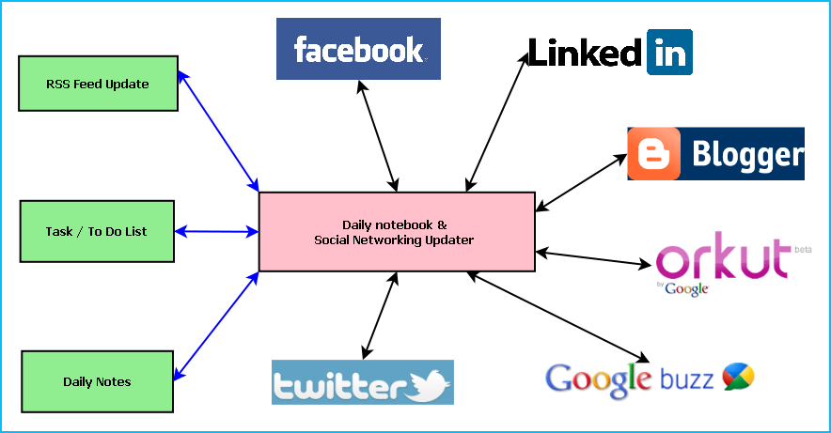
Figure: Overview of Daily notebook & Social Networking Updater
Main features of the Daily notebook & Social Networking Updater are:
- Maintaining daily notes
- Updating the status in Social Networking Sites and downloading the RSS feeds
- Facebook integration
- Twitter integration
- Blogger integration
- Linkedin integration
- Google buzz integration
- Orkut status integration
- Maintaining To Do/Task list
- Reminder/ alarm for scheduled task
- Printing of Notes, To Do & Tasks
- Archiving old data
- Searching Updates

Objective
- Single solution for updating any social networking sites
- Keeping track of daily activities
- Timely update whenever internet is available
- To simulate similar experience of Daily notebook.
- To be involved with full-fledged software development
- To know about new technologies like .NET, WPF, Facebook, Twitter.

Project Category:
This software will follow Object Oriented Programming Paradigm and use below mentioned areas.
Front End/ GUI Tools: Visual Studio 2010, .NET 4, C#, WPF
Backend: MySQL 5.5.15
Internet Technologies: HTML, JavaScript, PHP, Google App Framework, facebook,SDK,twitterSDK,LinkedIn SDK.
Operating Systems: Windows XP, Windows 7
Applications: PC Utility application

Hardware and Software Specification

Hardware Requirement
- Disc capacity : 10 MB of available hard disk space
- RAM : 1 GB (32 Bit) or 2 GB (64 Bit)
- Processor : 1.6GHz or faster
- DVD-ROM Drive / USB Port

Software Requirement
- Windows XP (x86) with Service Pack 3 / Windows Vista (x86 & x64) with
Service Pack 2 / Windows 7 (x86 & x64)
- Microsoft .NET 4.0

Project Structure:

Tools/Platforms used (Hardware/Software):

Hardware:
- Laptop with 2GHZ processor
- 2 GB RAM
- 320 GB hard disk (NTFS File System)
- 8 GB USB Pen Drive (FAT File System)

Software:
- Windows XP (x86) with Service Pack 3 / Windows Vista (x86) with Service Pack 2 / Windows 7 (x86)
- Microsoft .NET 4.0
- Windows Presentation Framework(WPF)
- Windows Communication Framework(WCF)
- Visual Studio 2010 Express Edition (IDE)
- MySQL database
- Dia for Diagram Drawing & Modeling.
- Google App Framework
- Facebook Php Sdk & FBML
- Twitter Sdk
- LinkedIn Sdk
- RSS Feed Burner Sdk

REQUIREMENTS AND ANALYSIS

Problem Definition

Requirements Specification

Functional Requirement

Register User
Introduction:
Register a new User.
Input:
Relevant User data like name, user id, password, date of birth etc.
Processing:
The DNBSN will create a new user entry.
Output:
The DNBSN will generate a user to use the application.

Login User
Introduction:
Logging in as an existing User.
Input:
User will provide user id, password.
Processing:
The DNBSN will check the authorization of the particular user.
Output:
The DNBSN will allow accessing feature to the user if the given data match with the internal information, otherwise denying user.

Update Note or Event
Introduction:
User can add note or event.
Input:
User will compose note or event for update to note book or social site. And select the option where he wishes to update the event.
Processing:
The DNBSN will create a new event for note book and share the event to the selected social site.
Output:
The DNBSN will save event in note book and share it in social site.

Load Google Map
Introduction:
User can load Google map through DNBSN.
Input:
Current location
Processing:
The DNBSN will get location from google map.
Output:
The DNBSN will display the particular location.

Share event in Google calendar
Introduction:
User can share event in google calendar through DNBSN.
Input:
The user selects the event from note book to upload in google calendar.
Processing:
The DNBSN will upload event in calendar.
Output:
The google calendar will display the particular event.

Search Event
Introduction:
User can search event.
Input:
He will enter data like key word or date etc.
Processing:
The DNBSN will search for the requirement.
Output:
The DNBSN will display the search result.

Add Contact
Introduction:
The DNBSN will Store a new Contact.
Input:
Relevant contact data like name, e-mail id, mobile no, fax no. address, blood group etc.
Processing:
Admin will enter the data in the DNBSN and create a new Donor entry.
Output:
The DNBSN will generate a contact detail for future reference.

Add To Do
Introduction:
The DNBSN will Store a new task in To Do.
Input:
Relevant task data like task detail, priority etc.
Processing:
Admin will enter the data in the DNBSN and create a new task entry.
Output:
The DNBSN will generate a task detail.

Technical Specification

Planning and Scheduling

Gantt chart

Tracking Gantt

Pert Chart

Scope of the Solution

Analysis

Context Diagram
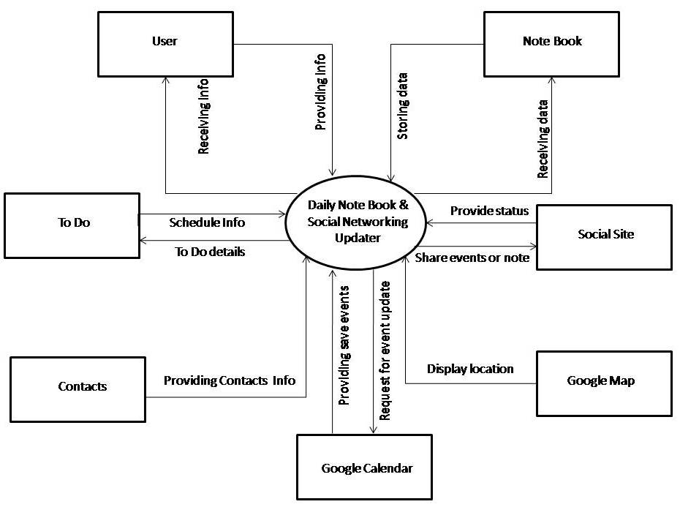

0-Level DFD
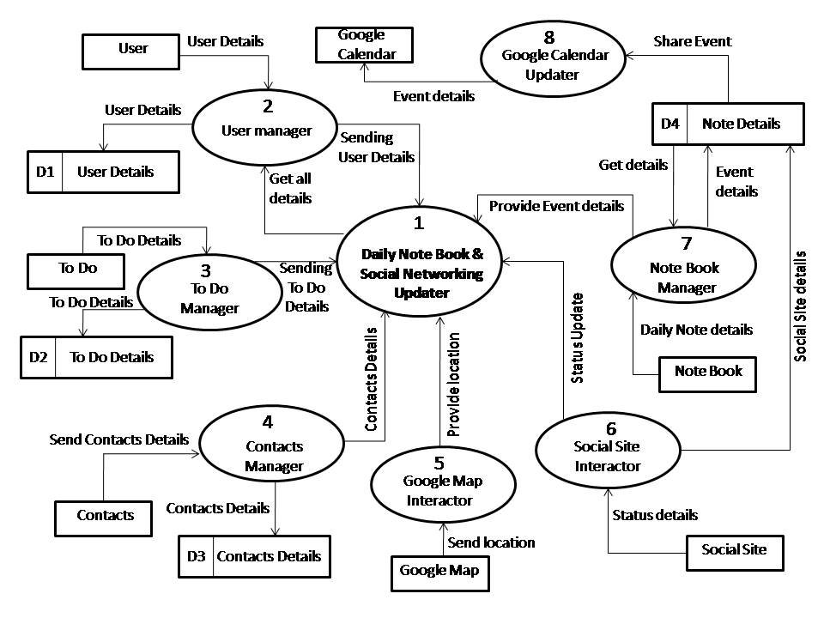

1-Level DFD
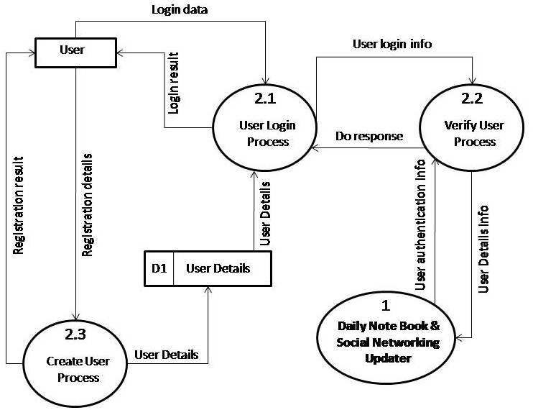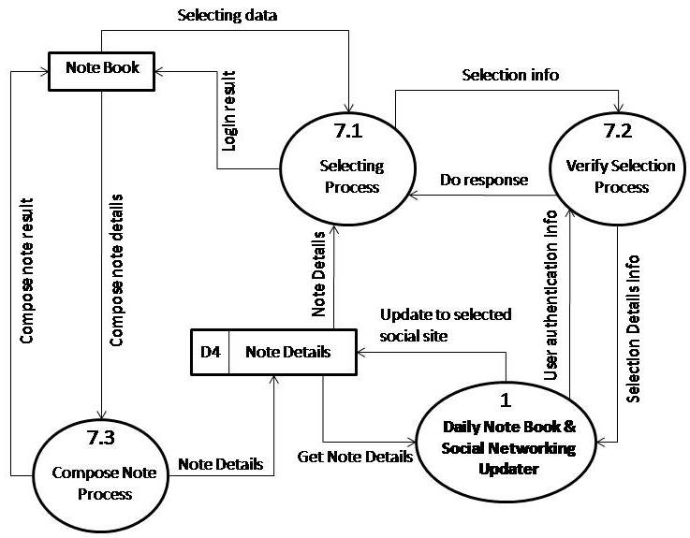

2-Level DFD
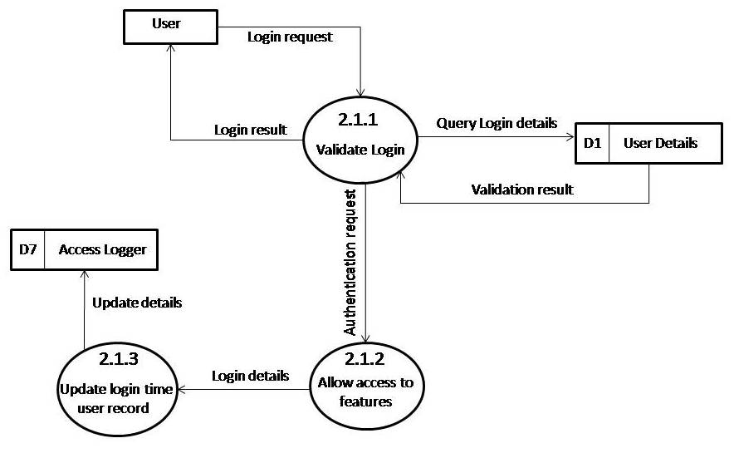

E-R Diagram
We will design a RDBMS for Daily notebook & Social Networking Updater. The entities and their attributes are listed below. Attributes in Bold letter is the unique key.
Entities | Attributes
Note | Note Id, Content, Time, Size, Web Service id, user
RSS Feed | RSS Feed Id , Web Service Id, Content, time, size
Daily notebook & Social Networking Updater | Sw Id, Web Services Supported, Users, Size
User | User Id, Name, Social Network Data, Preferences.
Web Service | Web Service Id, Authentication Data, Feed Data, Preferences.

Relationship between Entities:
- Daily notebook & Social Networking Updater has User → 1 : N
- Users post Notes → 1 : N
- Web Service generates Feeds → M : N

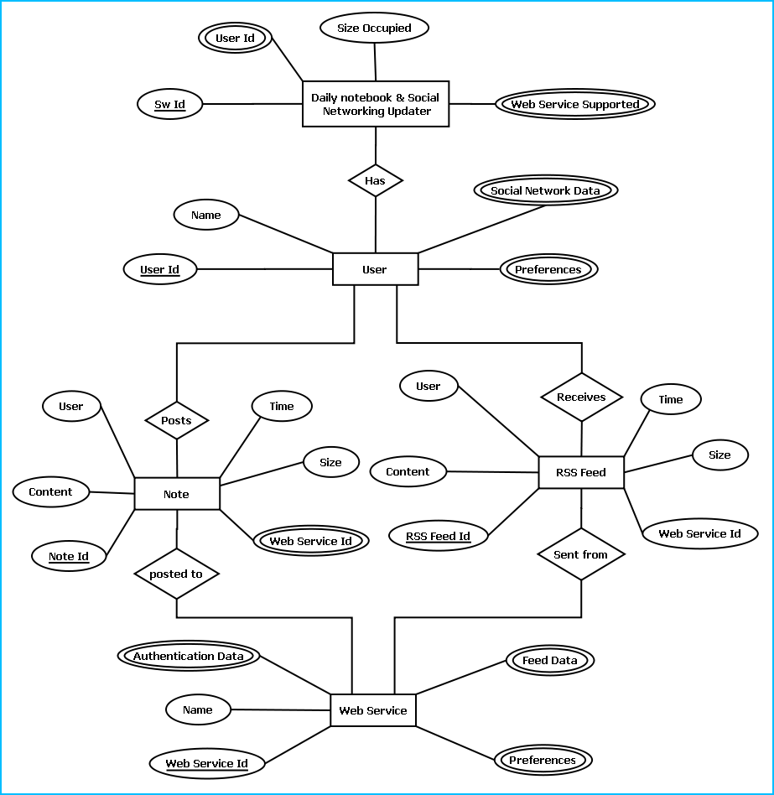
E-R Diagram of Daily notebook & Social Networking Updater

Class Diagram

Database & Table Details

Complete Structure

Module Description

Estimation

Data Structure

Implementation Methodology

List of Reports

Implementation of Security Mechanism at Various Levels

Future Scope and Further enhancement of the project:

- Now it will display the text based RSS feeds and link of the multimedia contents. We will display the Multimedia contents like Video, Audio & Image in future.
- To support UNIX / Linux Based Operating systems.
- To Support Mobile Operating systems for Symbian, Meego & Android.

Bibliography
- http://en.wikipedia.org
- http://msdn.microsoft.com/en-us/
- http://www.microsoft.com/en-us/default.aspx
- http://www.codeplex.com/
- http://stackoverflow.com/
- http://www.codeguru.com/
- http://www.w3schools.com
- www.mysql.org

----------------------------- Thank You-------------------------

